KS Electronics, Inc dba Ram Technologies

322 Paseo Sonrisa. Walnut, CA 91789 Tel: 909-869-8826 Fax: 909-869-8954
Website: www.ramtech2000.com Email: sales@ramtech2000.com
Account Application
Legal Business Name |  | Owner / President
DBA (Doing Business As) |  | Authorized Purchaser
Shipping/Billing Address |  | E-mail Address
City |  | Account Payable Contact Name
State Zip Code |  | Account Payable E-mail Address
Business Phone Number |  | Business Website Address
Business Fax Number |  | Ram Tech Sales Rep

This company is a: Sole Proprietorship Partnership LLC Corporation
Federal Tax I.D. Number: _______________________ Annual Sales Volume: ________________
Date Business was founded: _____________________ Fiscal Year end: _____________________
Length of time at this address: ________year(s) _______month(s)
Facilities: own lease ___________sq ft

Trade References
Company Name |  | Contact Person |  | Phone No. |  | Fax No. |  | Net Terms |  | Amount
Company Name |  | Contact Person |  | Phone No. |  | Fax No. |  | Net Terms |  | Amount
Company Name |  | Contact Person |  | Phone No. |  | Fax No. |  | Net Terms |  | Amount
Company Name |  | Contact Person |  | Phone No. |  | Fax No. |  | Net Terms |  | Amount
Company Name |  | Contact Person |  | Phone No. |  | Fax No. |  | Net Terms |  | Amount

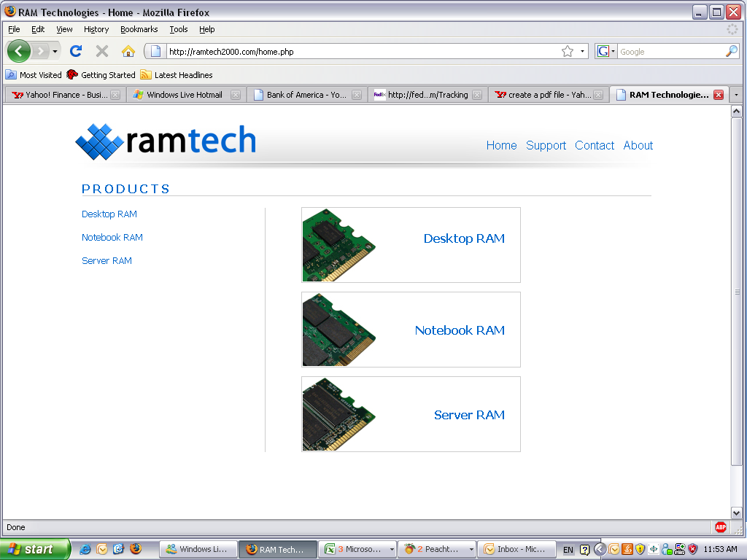

KSE dba Ram Technologies
322 Paseo Sonrisa, Walnut, CA, 91789 USA
T:(909)869-8826 F:(909)869-8954

Credit Card Information & Authorization Form

Dear Customer:

Please provide us with your credit card information and authorization so we can process your order. Your signature confirms you gave authorization to KS Electronics Inc dba Ram Technologies to charge your credit card for your purchases. All information will be handled in strict confidence.

Card Holder Name
Company Name
Card Holder Billing Address
Street Address
City
State/Province
Zip Code |  | Country
Home Phone Number
Work Phone Number
Email
Card Type | Visa MasterCard  Discover American Express
Credit Card Number
Credit Card Expiration Date
Credit Card CVV2 Number

Card Holder Signature: ____________________________________ Date:____ ______

KS Electronics, Inc dba Ram Technologies

322 Paseo Sonrisa. Walnut, CA 91789 Tel: 909-869-8826 Fax: 909-869-8954
Website: www.ramtech2000.com Email: sales@ramtech2000.com

Transit Insurance
Dear Valued Customer,

In order to serve you better and help keep your cost down, please complete this form and fax/mail us a copy of your Certificate of Liability Insurance.

No, we do not have any transit insurance coverage; please apply insurance on all future orders. We understand that there will be a 0.05% charge for the insurance coverage. The 0.05% will be charged based on the total invoice amount.

Do NOT add any transit insurance onto any shipments. We hereby agrees NOT to insure the package and holds KSE dba Ram Technologies harmless from loss, stolen, damage during transit for goods purchased from KSE dba Ram Technologies. We understand our responsibility of this decision and agree to pay the goods in full when payment term is due.

Yes, we have our own insurance policy (please attach an up-to-date insurance certificate). Do NOT add any transit insurance onto any future shipments. In the event of any loss or damage during transit, we will fulfill our obligation to KSE dba Ram Technologies and recover the associated loss through our own transit insurance.

If you have any questions, please feel free to give us a call.

Thank you for your help.

NOTE: Please be aware that shipments from Ram Technologies are always F.O.B. shipping point. In the event of a lost, stolen, or damaged package, you are still required to pay for that package within your agreed upon terms with KSE dba Ram Technologies.
No exceptions will be made.

The selected option above is authorized by:

Company Name

Authorized Person’s Name | Title
Authorized Signature | Date

